
Help shape safer journeys for neurodivergent children and young people.
The Road Safety Foundation is carrying out an important research project funded by the Road Safety Trust to better understand how neurodivergent children of all ages and young people aged 16–24 experience roads and streets.
If you're a parent or carer of a neurodivergent child or young person, or a neurodivergent young person yourself, we'd love to hear what issues you have on your journey to school.
Simply download the YEA - Youth Engagement App from the App Store or Google Play and sign up today. If you are under 13, your parent/ carer/ guardian will need to sign up for you and report on your behalf. If you are aged 13-18, please sign up and provide your parent/carer/guardian’s email address for their approval before you can use the app. If you are over 18, you can simply sign up and use the app yourself.
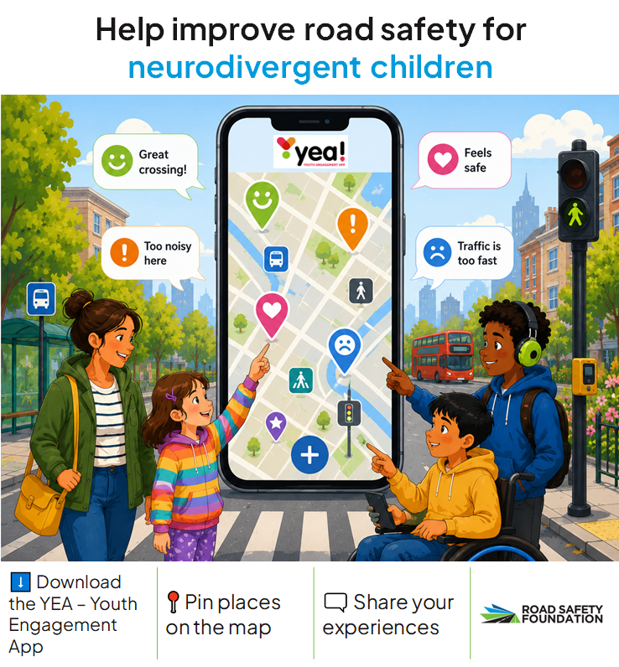

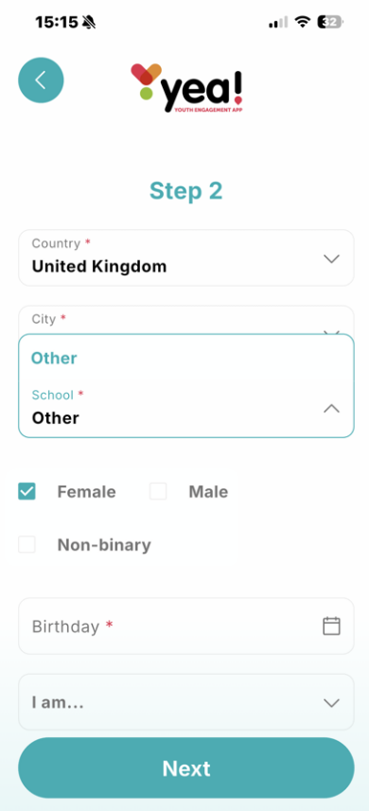
When you are registering for the app, it will ask you which city you are in and which school you attend, please click ‘other’.

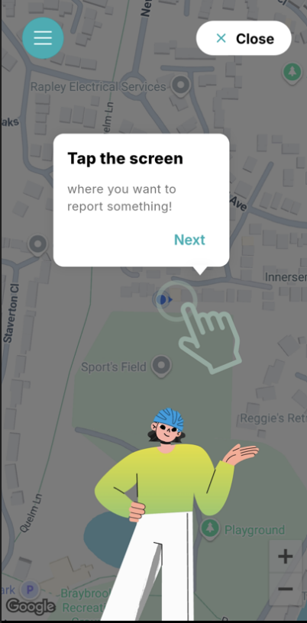
Once you are able to access the app, use the search function or move around the map to find your area, press and hold the screen and drop a ‘pin’ onto the map to show where you have issues. There are a number of questions which will follow this, please do complete these. PLEASE DO NOT USE THE APP NEXT TO THE ROAD, PLEASE RECORD YOUR THOUGHTS WHEN YOU ARE AT HOME OR AT YOUR DESTINATION.


If you need a tour of the app, please find it by pressing the three lines in the top left hand corner of the screen and then under the menu, press settings and then user guide.
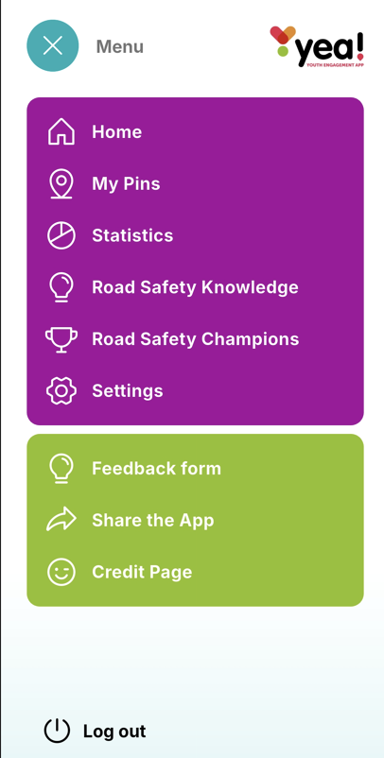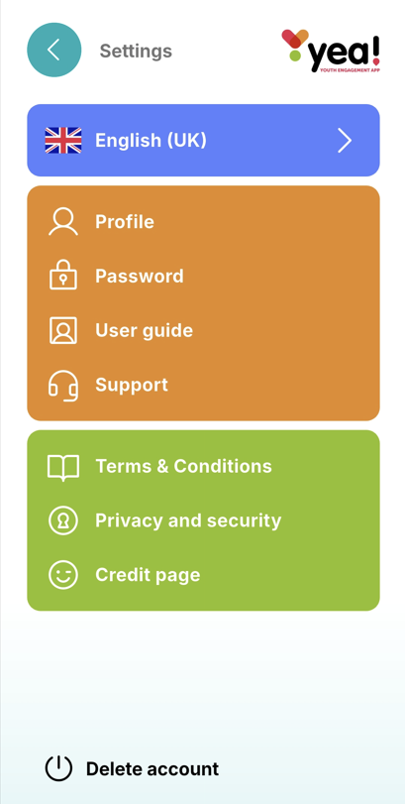
Please contact us if you have any queries.
Road Safety Foundation icanhelp@roadsafetyfoundation.org

